## Project Structure

auto.php – Main script file, fetch data from db, and updates spreadsheet

apiClient.php – Returns an authorized API client

credentials.json – It stores OAuth 2.0 Client IDs for your Google Project

token.json – Stores user’s access and refresh tokens, this is created automatically when the authorization flow completes for the first time

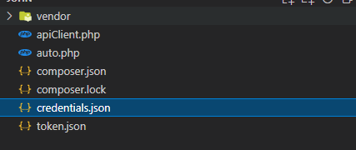

## Project configuration

**Generate credentials.json**

Visit Google Cloud Console and create a new project and enable google sheets api

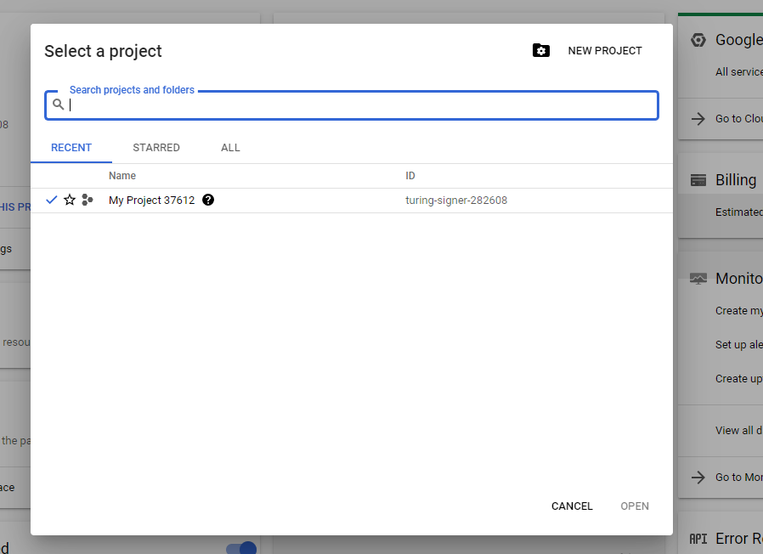

After Google Sheets Api enabled, set up OAuth consent screen

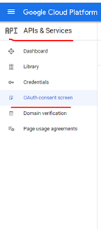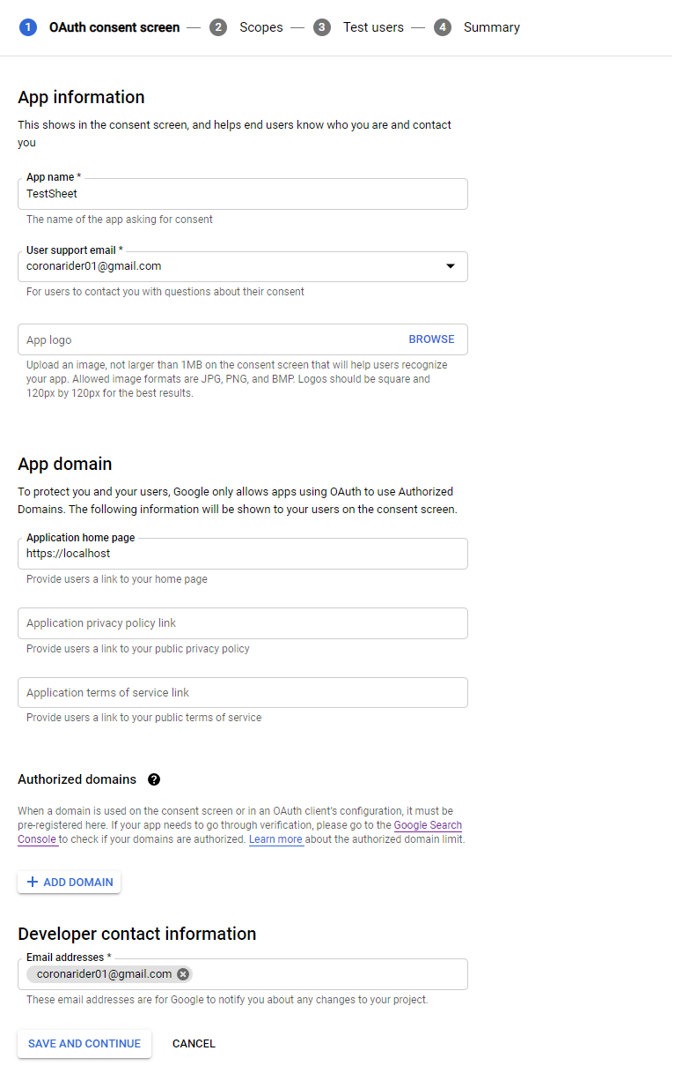

Next, You need to add OAuth 2.0 Client ID

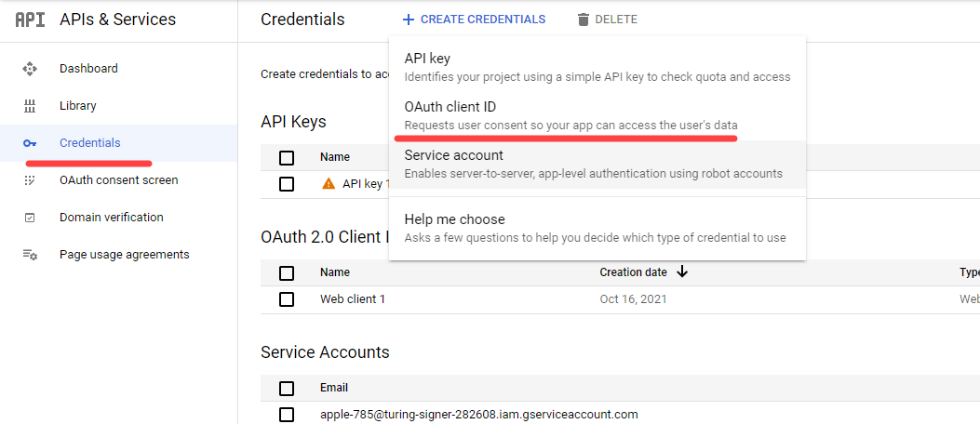

There are several steps and you can fill the first step fields as below

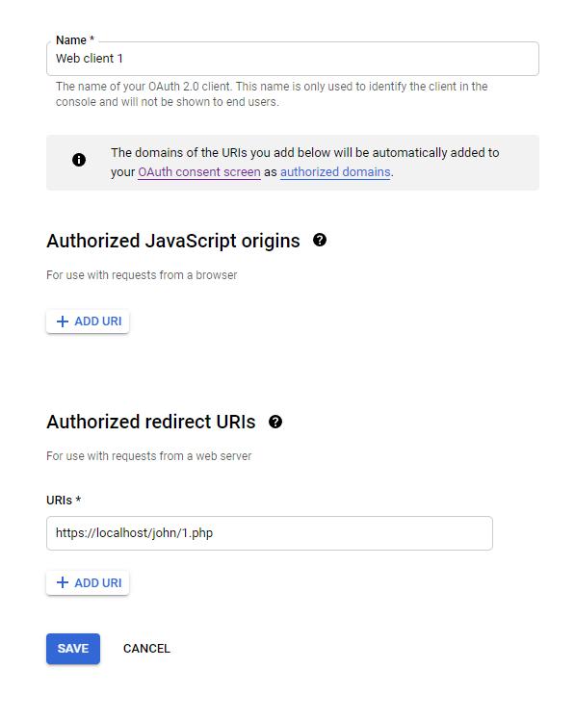

On Test users step, you should add the sheet owner/editor address to the test user list

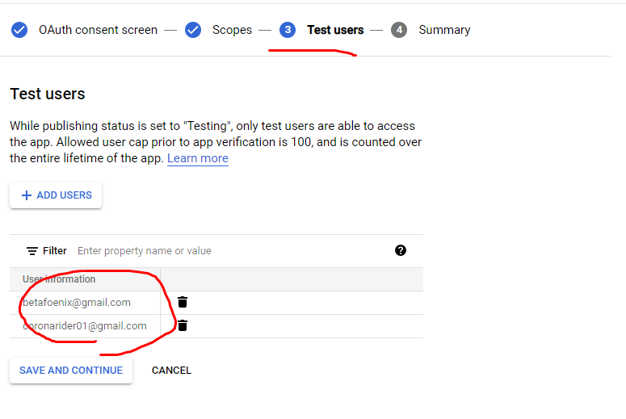

Finally you can download json file containing your client id and secret

After download, place the file to the project directory with name ‘credentials.json’

**Install libraries**

You can run composer install at root directory of the project

At this time, project structure will be same as below image

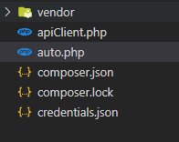

Now you can run the project by using command php auto.php

**Running Project**

To grant read/edit access to your google sheet, the sheet owner/editor must approves the access request

We con do this by displaying consent screen to the user

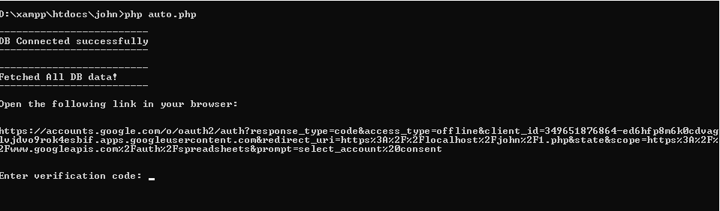

For the first time, you run the command, you could see a link for request authorization

Copy the link and open it with browser(chrome)

You could see consent screen

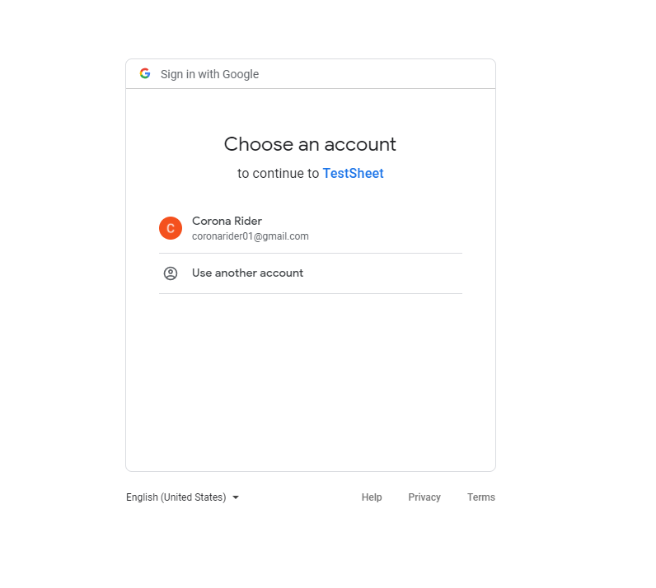

Move forward by clicking ‘Next’

Finally you will get redirection link you configured on Google OAuth Client

In my case, it is sth like this



Here you could see code params

4/0AX4XfWgnZnqO0QeBXfXr8zspoHvRFUwJ_F4fB2oZH4HgH_1ey0Fal1hEJoR8Ar7jykX2FQ

Copy this code, go to console again, input the code

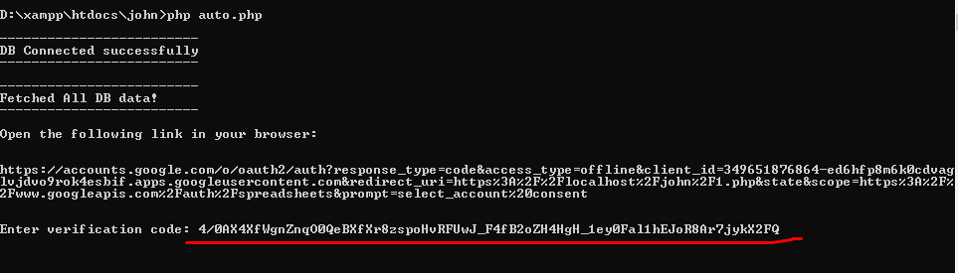

Hit Enter

You could see the message showing that the sheet was updated

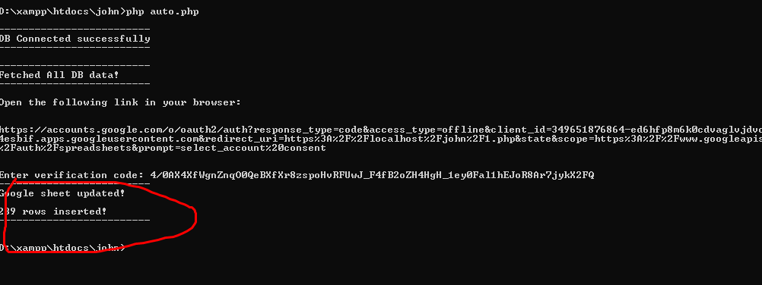

If you check the project directory, you could see new token.json generated

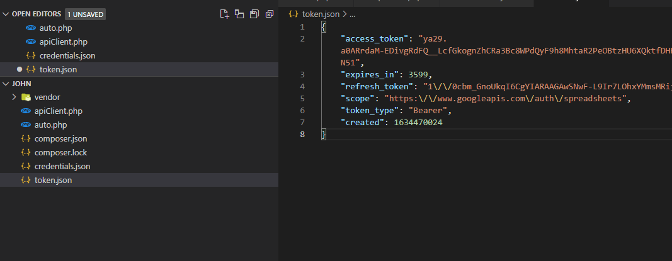

Here you have access token and refresh token

After token.json generated, when you run the command again, it will gets the token from this json and update the sheet automatically

